BlogNest Enterprise Project Specification & Architecture
Detailed System Architecture, Complete Entity Specifications, API Workflow, and Database Schema Design

1. Executive Summary & System Architecture
BlogNest is an advanced, scalable content management and publishing ecosystem engineered to deliver seamless digital blogging experiences. The platform empowers multiple user personas—ranging from standard readers to credentialed authors and system administrators—to publish, categorize, discover, and interact with rich-media articles.
The architectural framework adopts a modular NoSQL database design (optimized for MongoDB collections), ensuring high performance under heavy read/write loads. Core functionalities include secure password hashing, dynamic content categorization, real-time comment threading, and robust author attribution pipelines.
Visual System Architecture & ER Diagram
The comprehensive ER diagram below maps out the core data entities, structural cardinalities, and relationship pathways across the entire BlogNest application stack.
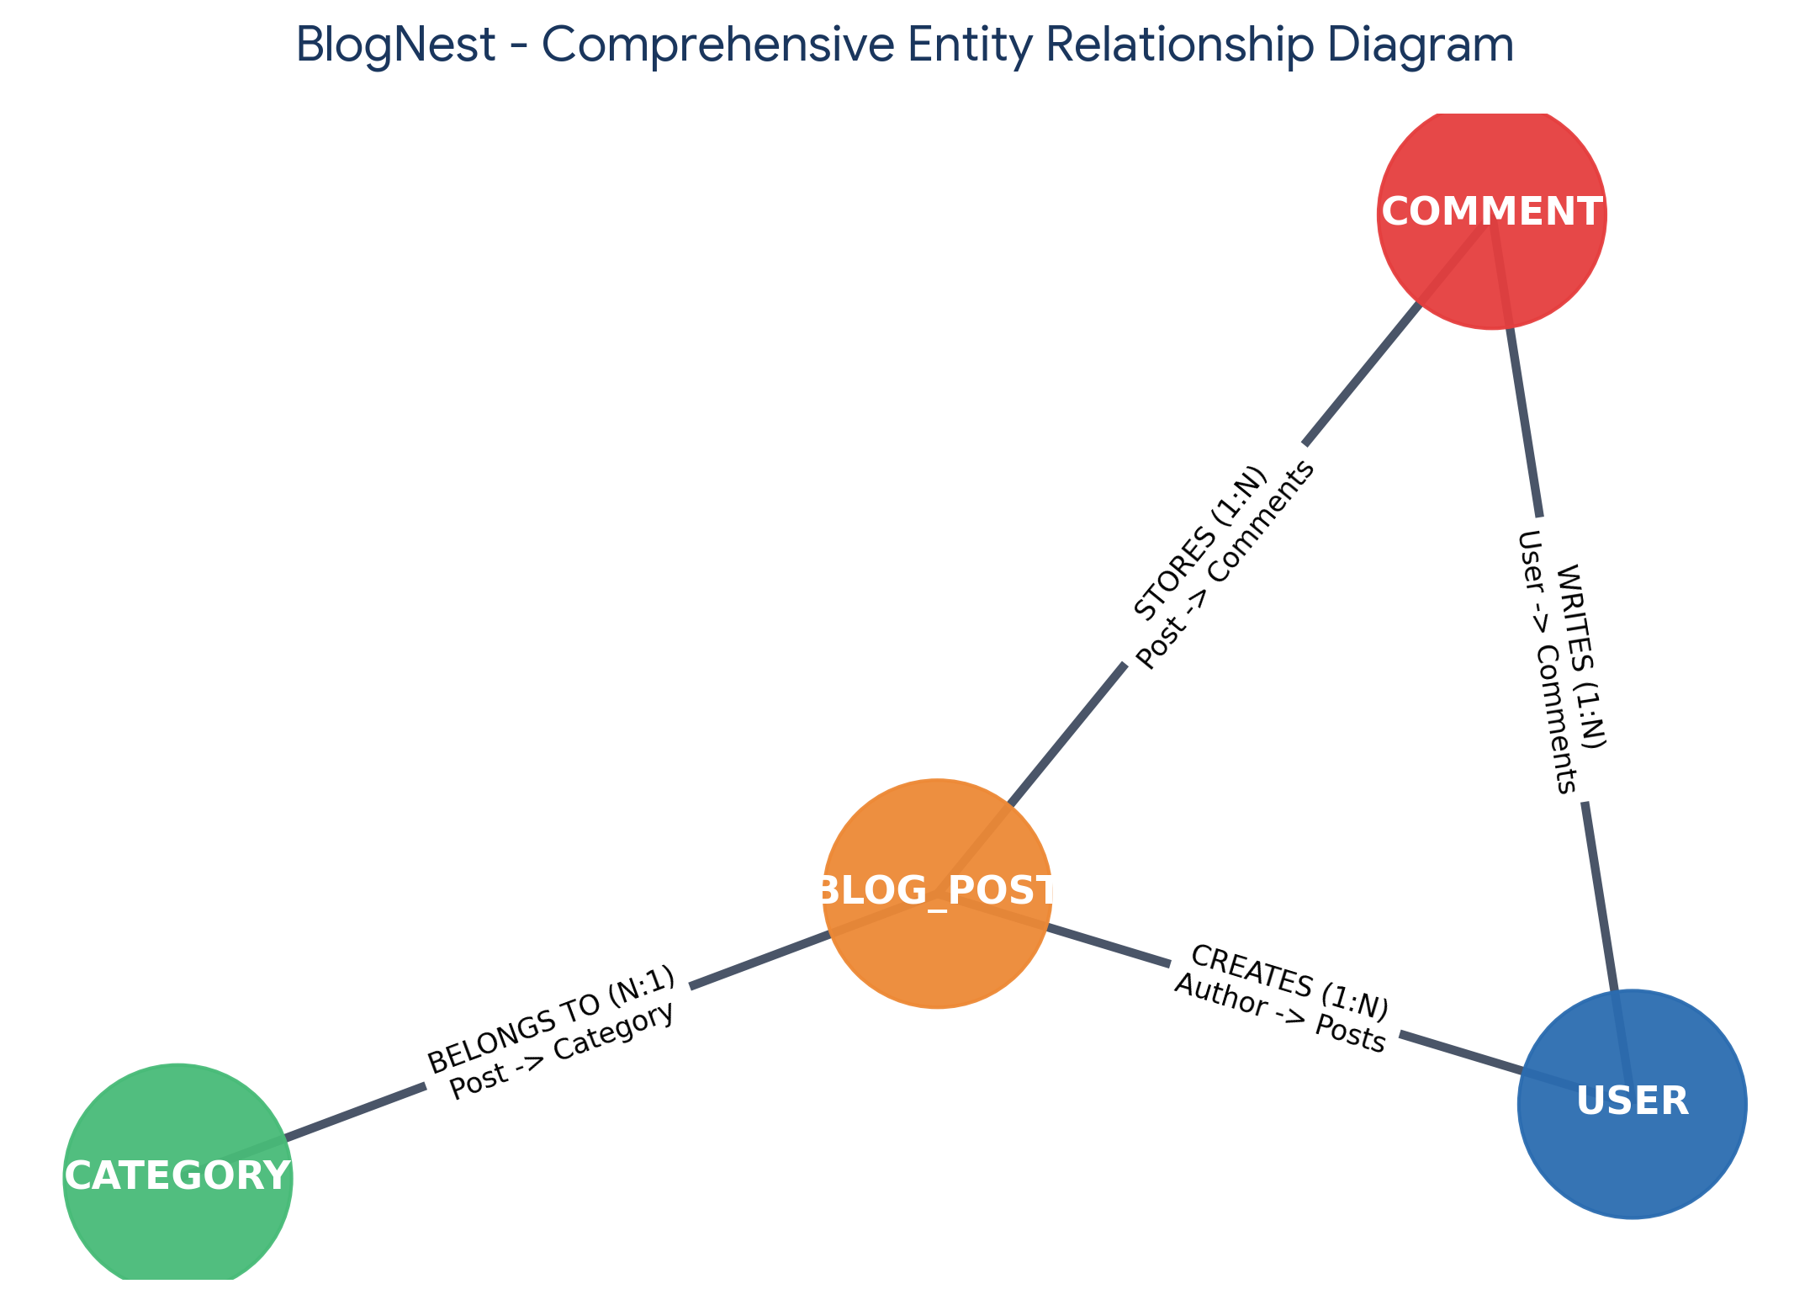
2. Comprehensive Entity Specifications & Schema Design
The database schema comprises four foundational collections designed to maintain rigorous relational integrity while leveraging the flexibility of document databases.
User Entity Collection
Field Name | Data Type & Constraints | Detailed Specification
_id | Primary Key (ObjectId) | Globally unique document identifier generated automatically by the database engine.
name | String (Required) | Full legal or display name of the registered user account.
email | String (Unique, Indexed) | Primary email address used for system authentication and account recovery.
password | String (Hashed, Encrypted) | Bcrypt salted and hashed password string ensuring enterprise-grade credential security.
role | String (Default: 'reader') | Authorization privilege level (e.g., 'reader', 'author', 'admin') governing access controls.

Post Entity Collection
Field Name | Data Type & Constraints | Detailed Specification
_id | Primary Key (ObjectId) | Unique identifier representing an individual published blog article.
userID | Foreign Key (Ref: User) | Reference link mapping the article directly to its registered author.
name | String (Required, Indexed) | Compelling title or heading headline for the blog post.
photo | String / URL Pathway | External or hosted media pathway link pointing to the article's featured cover image.
message | String (Core Body Text) | Full-text rich content body of the blog publication.
likes | Number (Default: 0) | Accumulated counter tracking reader engagement and positive feedback votes.
timestamps | Boolean / ISODate | Automatic creation and update tracking timestamps (createdAt, updatedAt).

Category Entity Collection
Field Name | Data Type & Constraints | Detailed Specification
_id | Primary Key (ObjectId) | Unique identifier assigned to each topic category classification.
name | String (Required, Unique) | Title of the category (e.g., Technology, Software Engineering, Lifestyle).
description | String (Optional) | Comprehensive summary explaining the scope and focus of articles within the category.

Comment Entity Collection
Field Name | Data Type & Constraints | Detailed Specification
_id | Primary Key (ObjectId) | Unique record identifier for reader response feedback.
postId | Foreign Key (Ref: Post) | Target blog post association linking the comment to its parent article node.
userID | Foreign Key (Ref: User) | Author reference identifying which user submitted the comment response.
message | String (Required) | Text content body of the reader comment or discussion reply.
updatedAt | Timestamp | Tracking date and time of the latest comment revision or submission.

3. Structural Mappings & Business Logic Workflows
The interactions between entities define the core operational logic of the BlogNest application ecosystem:
- User to Post (One-to-Many): An authorized author account can generate, edit, archive, and publish multiple blog documents. Each post retains a strict foreign key reference back to the originating user profile.
- User to Comment (One-to-Many): Registered readers and community participants can post multiple comments across different articles, fostering dynamic user engagement and discussions.
- Post to Comment (One-to-Many): Every individual blog post functions as a container node storing multiple threaded reader comments, allowing structured retrieval of feedback associated with specific content.
- Category to Post (One-to-Many): Content categorization ensures that multiple blog articles are organized neatly under distinct topics, facilitating high-speed filtering and intuitive user navigation.

